Numerical Methods Coursework

In mathematics there are many equations that cannot be integrated by a normal algebraic method, and therefore these equations will have to be solved via numerical methods. My equation that I cannot solve analytically is . This equation as a graph looks like this between the values of -1 and 1:

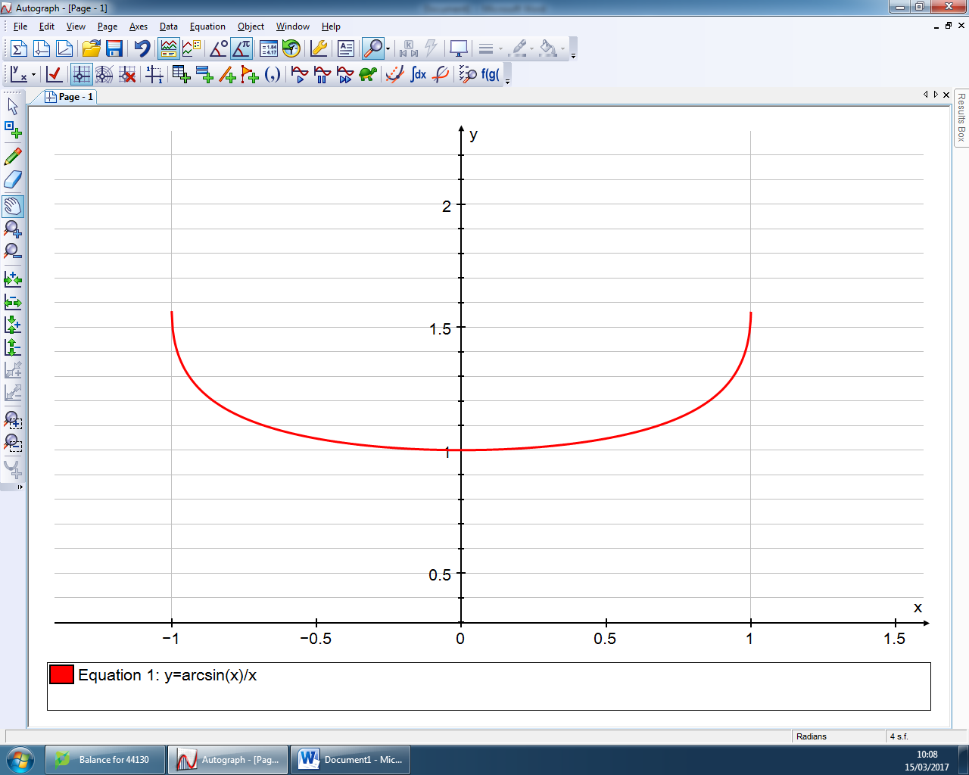

Figure 1: graph between the values -1 and 1.

I plotted this graph on a graph drawing software called Autograph, software that I could use in the future is called Desmos Graphing Calculator however Autograph is the ideal program due to it lends itself to be screenshotted onto a word document.

During this piece of work I will be using numerical methods on an Excel spreadsheet to integrate and calculate an estimate for the area under the curve bound by the regions 0 and 1 as shown below, outlined with the colour Green:



Figure 2: Area under the curve I will be trying to estimate between the limits 0-1.

I will be doing this by using the Midpoint rule, Trapezium rule and the Simpsons rule by starting with only one strip and then I will gradually use more strips to reach a more accurate estimation for the integral of the curve.

The equation of the midpoint rule is:

The equation of the Trapezium rule is:

The equation for the Simpsons rule is:

Where

I will be using these 3 rules to get an accurate estimation and using them as comparisons to each other. I will be using the iterations from . These 3 rules allow me to estimate the area under the curve in different circumstances.

The mid-point rule uses boxes or strips in equal intervals using the midpoint of the width (h) as the height of the strip. The graph below shows the Midpoint rule with h=0.2

Figure 3: The estimate for the area under the curve using the midpoint rule with thee width (h) as 0.2 which means there are 5 strips.

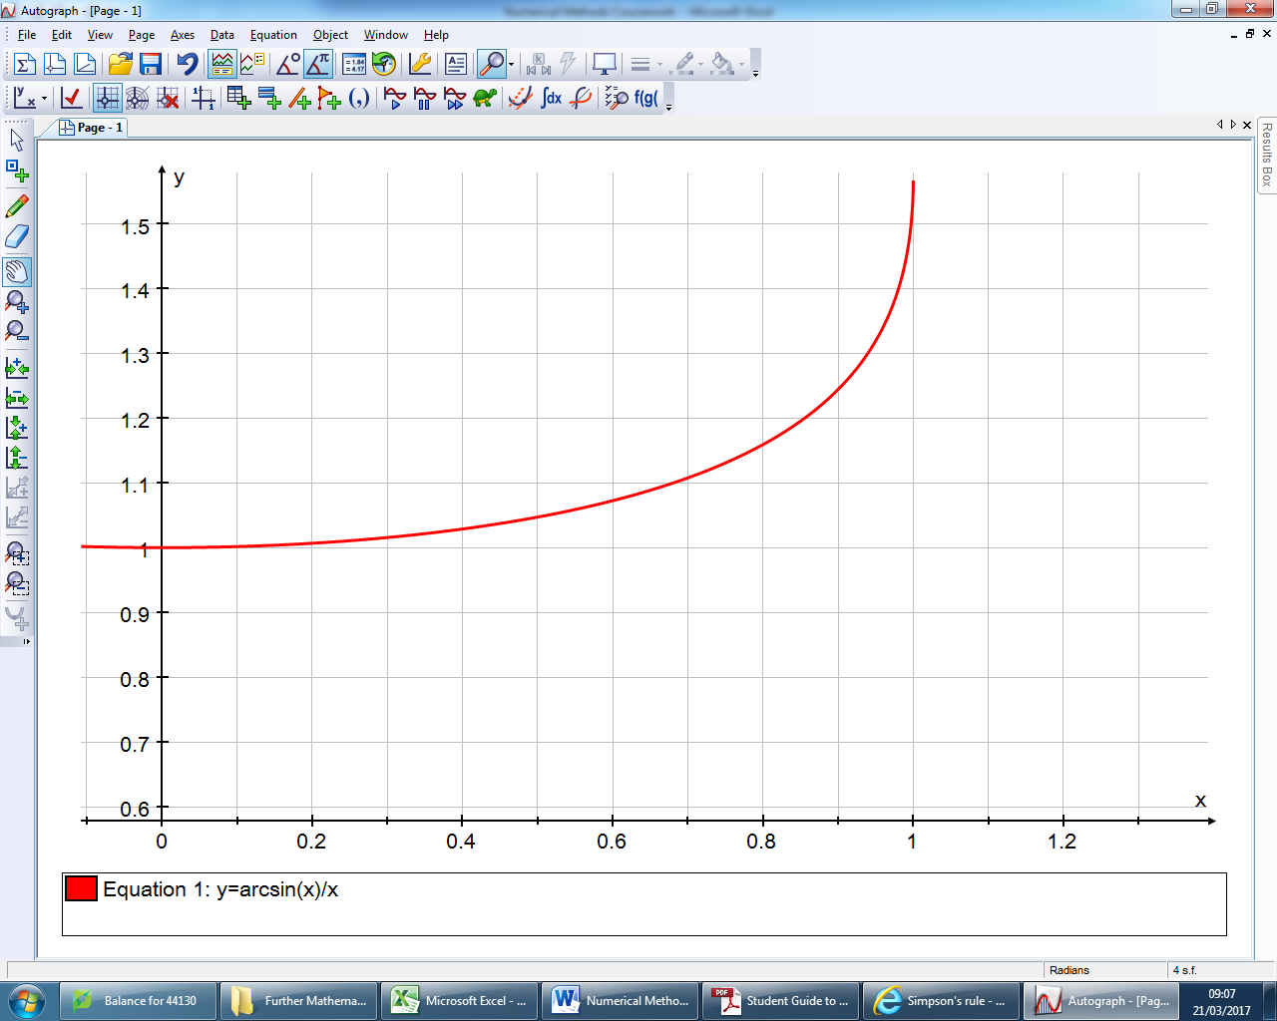

The Trapezium rule calculates the areas of trapezia similar to the strips under the curve with equal width, which gets smaller with each iteration and therefore more accurate. The graph shows the trapezium rule with h=0.2



[Type a quote from the document or the summary of an interesting point. You can position the text box anywhere in the document. Use the Drawing Tools tab to change the formatting of the pull quote text box.]

Figure 4: The estimate for the area under the curve using the curve using the Trapezium rule with the width (h) as 0.2 meaning there are 5 trapezia.

The Simpson’s rule is a combination of the two previous rules which cause it to be the most accurate estimation of the 3.

In figure 4 you can see a clear over estimation between the points 0.8 and 1.0; this is due to the sharp curve upwards.

Formula Calculation

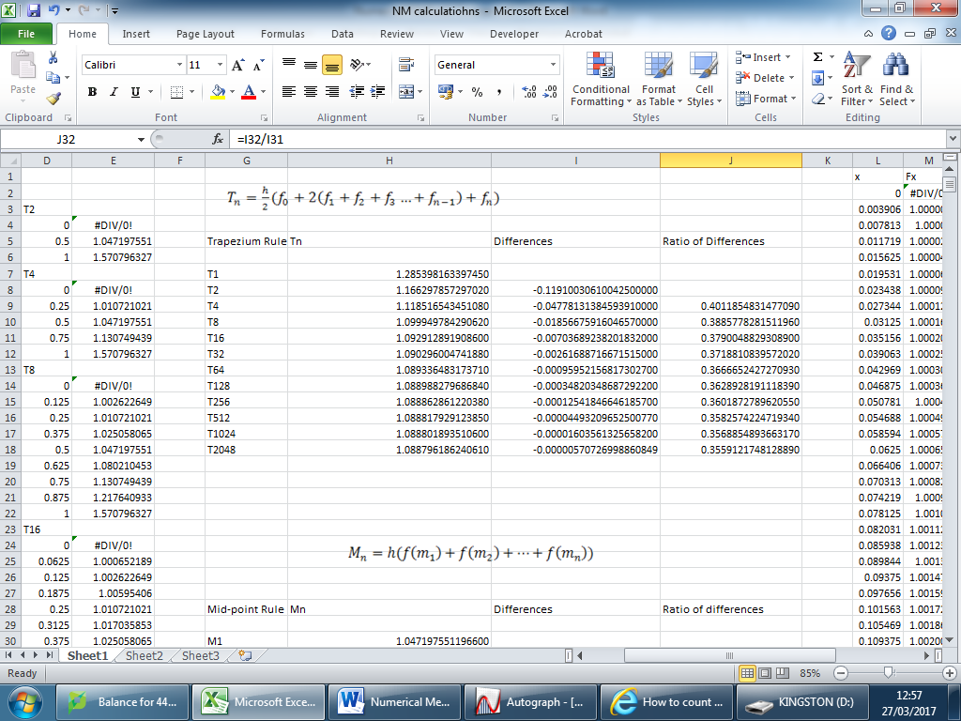

Figure 5: Trapezium rule using the function of my equation up to iteration 2048

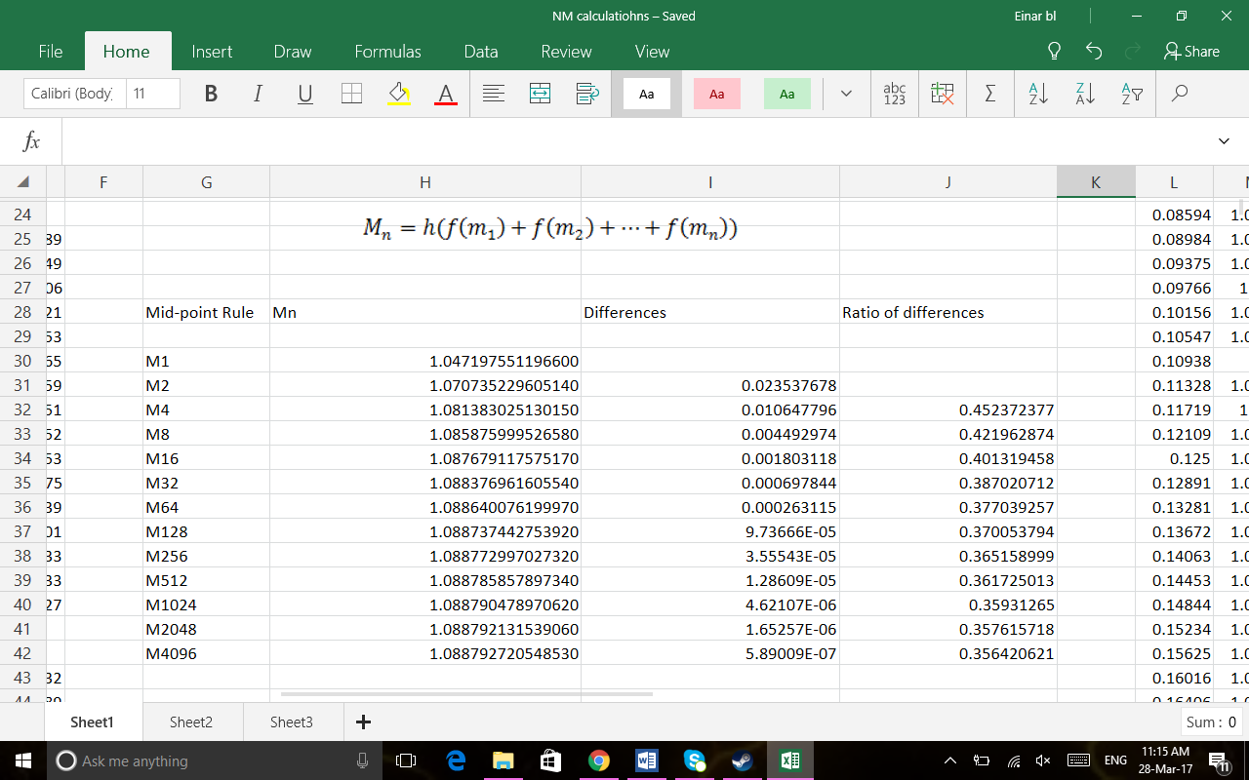In figure 5 above you can see my iterations which got for the trapezium rule, however for some reason I cannot get my ratio of differences to become close to ¼, instead they tend towards 0.35 instead. I’ve looked over my calculations and done them 3 more times but with no luck, the ratio still comes out to 0.35.

Figure 6: Midpoint rule using the function of my equation up to iteration 4096

Figure 6 shows my iterations of my equation using the midpoint rule, for this rule I had to calculate the midpoints between two numbers which is what I used in the midpoint rule equation, the function of the midpoint in the equation is denoted by . Similar to the trapezium rule the ration of differences became close to 0.35 again and still I do not know how this error could of taken place.

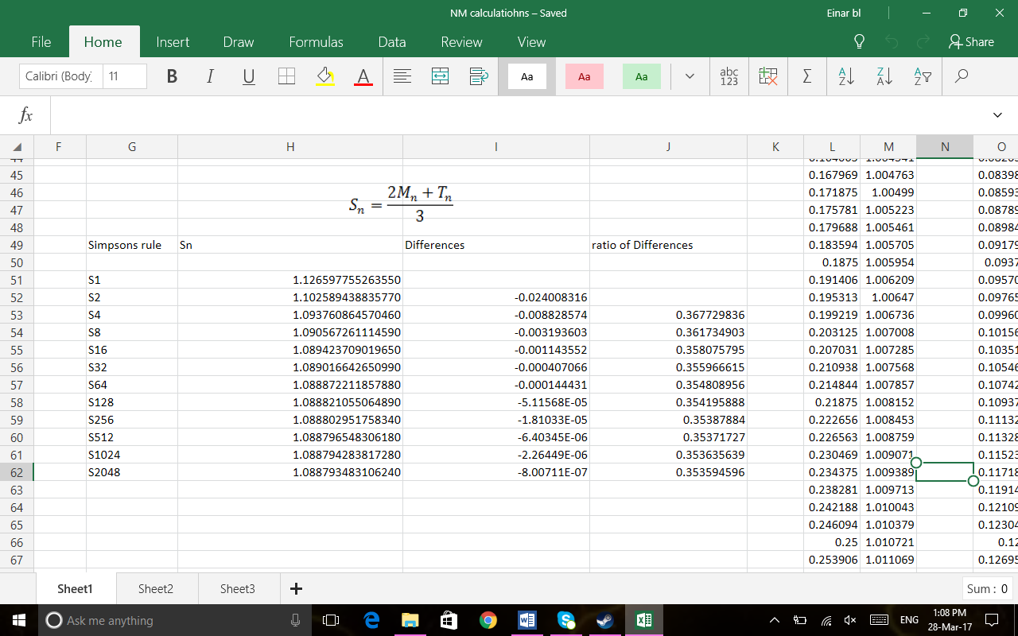

Figure 7: Simpson’s rule using the function of my equation up to iteration 2048

The table above shows my iterations of the Simpson’s rule, these numbers were generated from combining the midpoint rule and trapezium rule iterations. The same error shows up in this rule with the ratio of differences which shows 0.35 which doesn’t coincide with the original plan for numerical methods.

The error of 0.35 cannot be justified as I have multiple times re-done my spreadsheet but it still has the same outcome, however with my iterations of Tn, Mn and Sn are all the same to 5 significant figures which is seen as a high degree of accuracy.

In Figures 5 through 7 in the tables where Tn, Mn and Sn are shown I substituted the formula in for each of the rules to get those numbers, the tables below show what I did in Microsoft Excel for each rule.

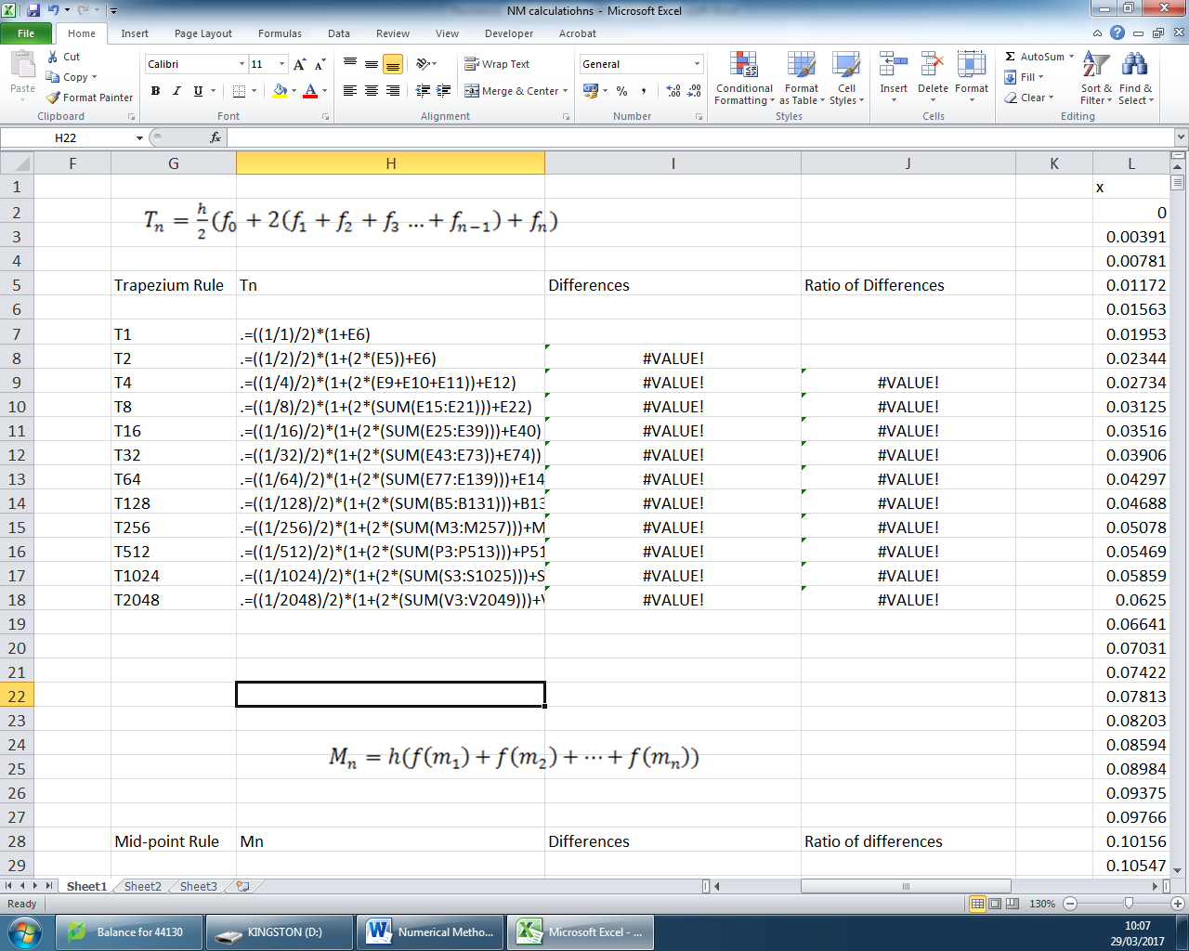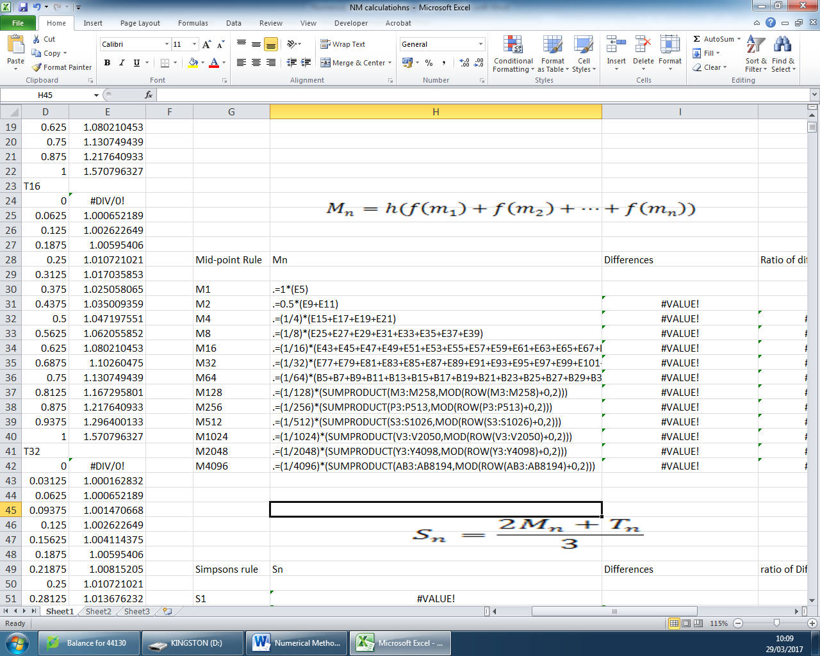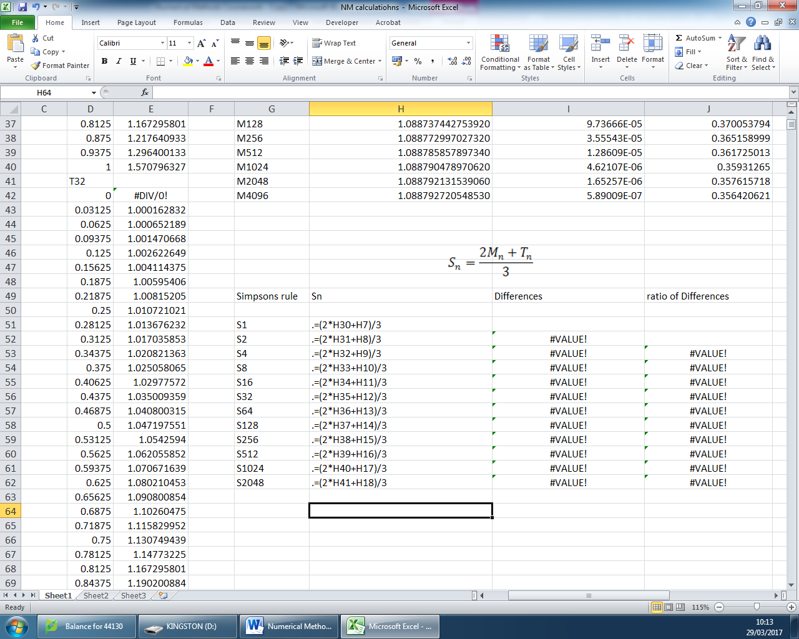

Figure 8: These tables are showing the formulas I used to get the iterations for each of my 3 rules.

R = rules (eg.T, M, S), for figures 5-7 the differences is calculated from doing for each iteration, the ratio of differences is shown as .

Error Analysis

In my coursework I encountered some errors, including an error that I was not able to understand and fix. Due to this error it has hindered my progress with extrapolation as my ratio of differences comes out to being 0.35 instead of 0.25, this error of 0.1 shows up in each rule including the Simpson’s rule.

A common error that everyone will encounter is due to the Trapezium and Midpoint rule are over-estimates and under-estimates respectively, this helps us to narrow down what the true value is as we do not know that value.

Each iterations of the 3 formulas get closer and closer to the value as shown below with the trapezium rule using T2 – T64 with X being the unknown true value, and each iteration will get closer to the real value as with the same ratio of differences which should be 0.25

